
Microservice Architecture
Practical #1

Name | Harshal Kadam | Roll Number | 21306A1024
Subject/Course: | Microservice Architecture | Class | MSc IT
Topic | Installation of .NET SDK & Building First  Console APP | Sem | II
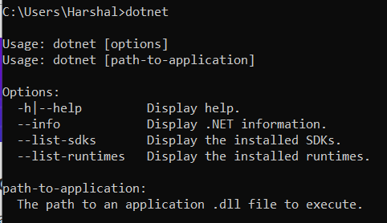
The native installers are primarily meant for developer's machines. The SDK is distributed using each supported platform's native install mechanism, such as DEB packages on Ubuntu or MSI bundles on Windows.
The .NET SDK is a set of libraries and tools that allow developers to create .NET applications and libraries. It contains the following components that are used to build and run applications:
- The .NET CLI.
- .NET libraries and runtime.
- The dotnet driver.
Overview of .NET SDK
Step 3: Create new app. Run command: dotnet new console -o MyApp then Run Command:
cd MyApp
Step 1: Download and Install the .net
Step 2: Checking if everything is installed correctly. Run command: dotnet
Building First Console App

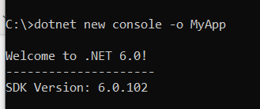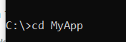
Step 4: Open the file Program.cs(C# source file) ; edit the file for what ouput we need.
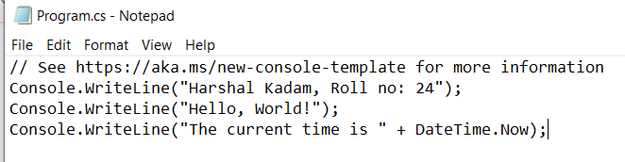
Step 5: Run the following commadn in folder where program.cs is present.
Run Command: dotnet run
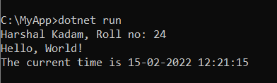

Microservice Architecture
Practical #2
Name |  | Harshal Kadam | Roll Number | 21306A1024
Subject/Course: |  | Microservice Architecture | Class | MSc IT
Topic |  | Building First ASP.NET Core App | Sem | II
Overview of MVC
 | The Model-View-Controller (MVC) architectural pattern separates an application into three main components: the model, the view, and the controller. The ASP.NET MVC framework provides an alternative to the ASP.NET Web Forms pattern for creating MVC-based Web applications. The ASP.NET MVC framework is a lightweight, highly testable presentation framework that (as with Web Forms-based applications) is integrated with existing ASP.NET features, such as master pages and membership-based authentication. The MVC framework is defined in the System.Web.Mvc namespace and is a fundamental, supported part of the System.Web namespace.

MVC is a standard design pattern that many developers are familiar with. Some types of Web applications will benefit from the MVC framework. Others will continue to use the traditional ASP.NET application pattern that is based on Web Forms and post backs. Other types of Web applications will combine the two approaches; neither approach excludes the other.

The MVC framework includes the following components: -

Models: - Model objects are the parts of the application that implement the logic for the application s data domain. Often, model objects retrieve and store model state in a database. For example, a Product object might retrieve information from a database, operate on it, and then write updated information back to a Products table in SQL Server.
Views: - Views are the components that display the application s user interface (UI). Typically, this UI is created from the model data. An example would be an edit view of a Products table that displays text boxes, drop- down lists, and check boxes based on the current state of a Products object.
Controllers: - Controllers are the components that handle user interaction, work with the model, and ultimately select a view to render that displays UI. In an MVC application, the view only displays information; the controller handles and responds to user input and interaction. For example, the controller handles query- string values, and passes these values to the model, which in turn queries the database by using the values.
Building First ASP.NET Core App
Step 1: Create a folder named ‘MyMVC’.
Step 2: Run Command in Command Prompt :” dotnet new mvc –auth none”
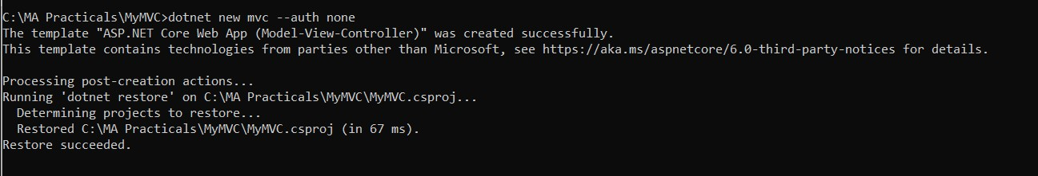
Step 3: Go to controllers’ folder and edit file HomeController.cd.

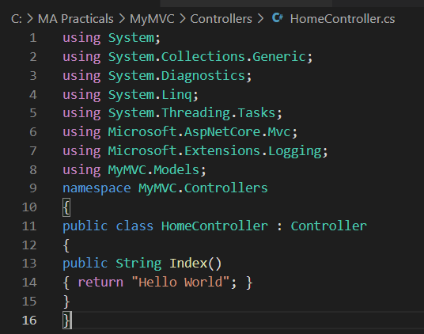
Step 4: Run Command: “ dotnet run”.
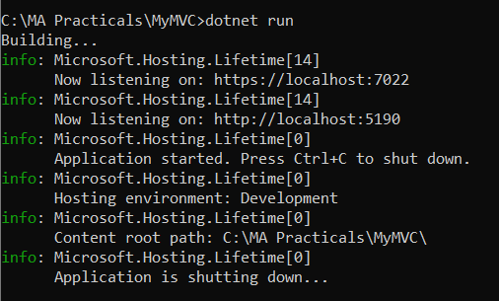
Step 5: Open any browser and type localhost with appropriate port shown in command prompt.

Step 6: Open the Models folder and create a new file named StockQuote.cs and include the following code.
using System; namespace MyMVC.Models
{
public class StockQuote
{
public string Symbol {get;set;}

public int Price{get;set;}
}}

Step 7: Open the file at path: C:\MA Practicals\MyMVC\Views\Home.index. Cshtml file.
@{
ViewData["Title"] = "Home Page";
}
<div>
Symbol: @Model.Symbol <br/> Price: $@Model.Price <br/>
</div>

Step 8: Go back to Controllers folder and edit the Homecontroller file. Include the following code:
using System;
using System.Collections.Generic; using System.Diagnostics;
using System.Linq;
using System.Threading.Tasks; using Microsoft.AspNetCore.Mvc;
using Microsoft.Extensions.Logging; using MyMVC.Models;
namespace MyMVC.Controllers
{
public class HomeController : Controller
{ public async Task <IActionResult> Index()
{
var model= new StockQuote{ Symbol="HELLO", Price=3200}; return View(model);
}
}
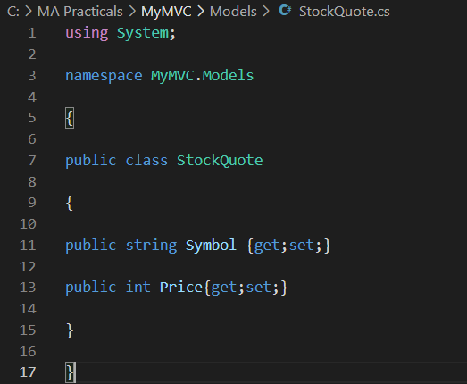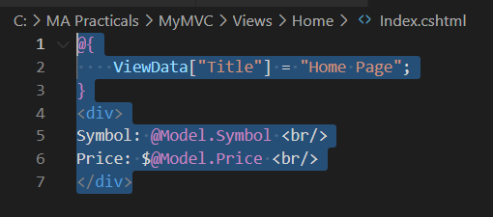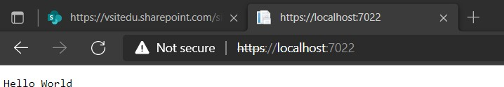

}
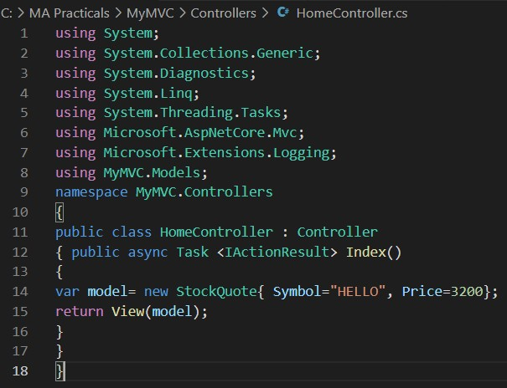

Step 9: Run command : dotnet run
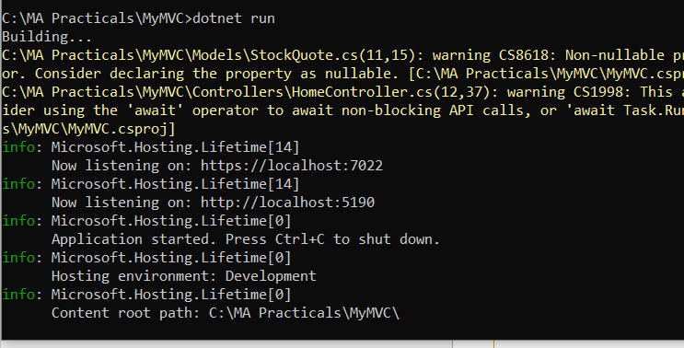
Step 10: Open any browser and type localhost with appropriate port shown in command prompt.

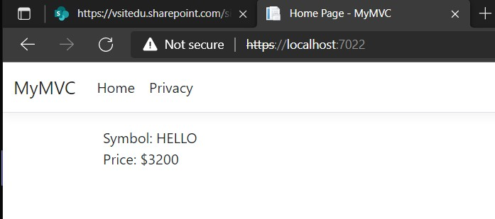

Microservice Architecture
Practical #3

Name | Harshal Kadam | Roll Number | 21306A1024
Subject/Course: | Microservice Architecture | Class | MSc IT
Topic | Working with Docker | Sem | II
Overview of Docker
Docker is an open platform for developing, shipping, and running applications. Docker enables you to separate your applications from your infrastructure so you can deliver software quickly. With Docker, you can manage your infrastructure in the same ways you manage your applications. By taking advantage of Docker’s methodologies for shipping, testing, and deploying code quickly, you can significantly reduce the delay between writing code and running it in production.
Working with Docker
Method 1: To pull and push images using docker
Login in our respective Docker accounts and write below given commands to check the docker version on respective device.

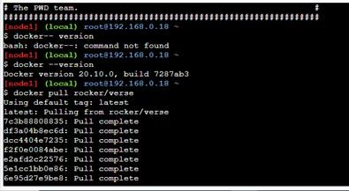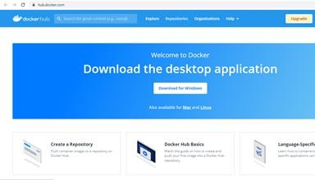
Step 2 : Create private repository and give name and description Note: you can create only one private repository in Free(Trial) Account
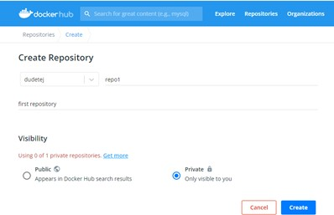

Step 3: Go to Docker Playground and login by entering your Docker account username and password

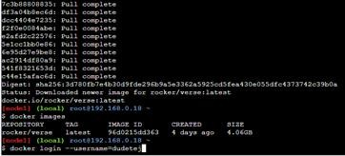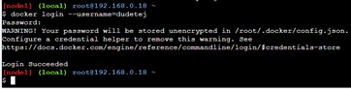
Step 4: Tag image into your repository, after running docker images.
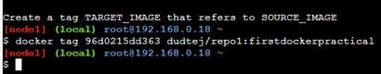
Step 5: Push the images in the created repository repo1
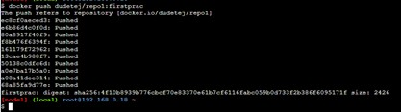

Step 7: Check Tags in Docker hub
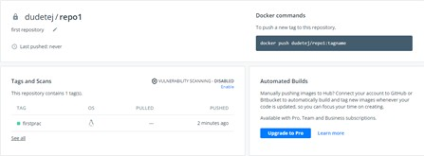
Note: you can also check whether the tags have been added under General tab on docker.com (Homepage)
Method 2:Build an image then push it to docker and run it

Microservice Architecture
Practical #4

Name | 21306A1024 | Roll Number | Harshal Kadam
Subject/Course: | Microservice Architecture | Class | MSc IT
Topic | Docker Desktop APP | Sem | II

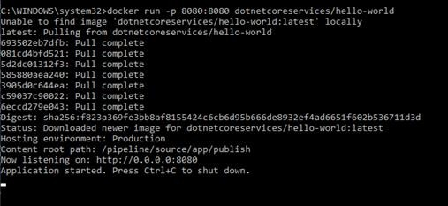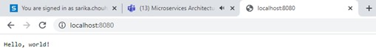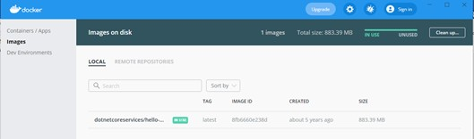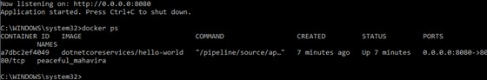Docker Desktop APP
Step 1: Open Docker app on your computer
Step 2: Open command prompt and run it as admin and write the given below code

Step 3: Go to your browser and enter the port number using localhost:port_no

Image will be added to your Docker application > images

Step 4: Press ctrl + c and run docker ps (process state)

Step 5: Kill the process with the id and run ps command to check whether the process is killed.

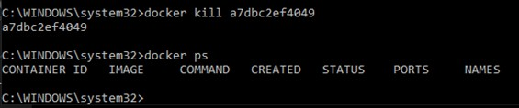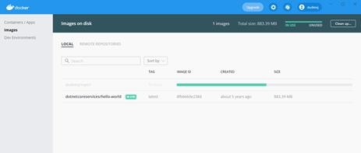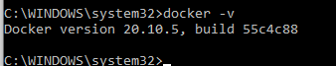
Step 6: Sign in to your Docker account and you can pull any existing images from your previously created repositories
Run various Docker Commands:
To check docker version –
Microservice Architecture
Practical #5

Name | Harshal Kadam | Roll Number | 21306A1024
Subject/Course: | Microservice Architecture | Class | MSc IT
Topic | Building ASP.Net core REST API | Sem | II
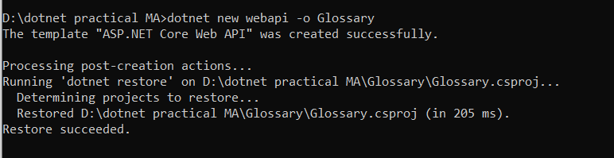
Step 2: open the glossary folder command: ‘ cd glossary’ then run command : ‘ dotnet run’
Step 1: ( If Dotnet is already installed) Open Command Prompt and run command ‘dotnet new webapi -o Glossary’
Building ASP.Net core REST API

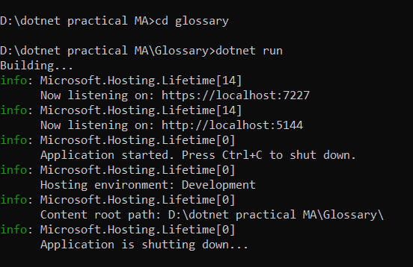
Step 3 : test weatherforecast class Output
Step 4: Delete Weatherforecast.cs and WeatherForecastController.cs file , create a new file glossaryitem.cs file and edit it .
Code:
namespace Glossary
{
public class GlossaryItem
{
public string Term { get; set; } public string Definition { get; set; }
}
}

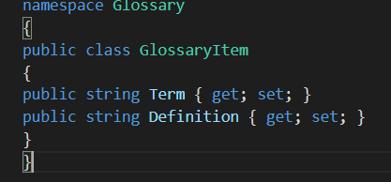
Step 5: Edit the GlossaryController.cs file in Controller folder Code:

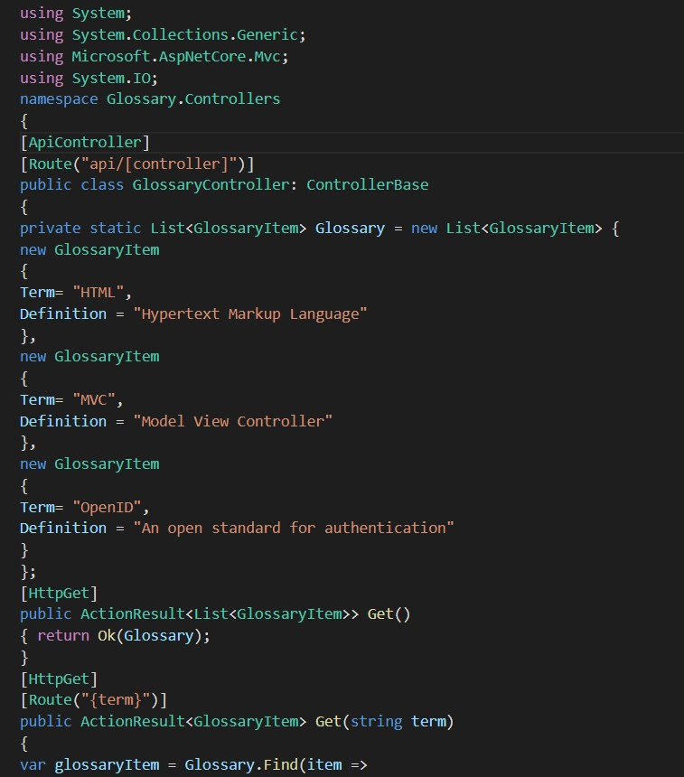

Step 6: Now again run command : ‘ dotnet run’ in Glossary folder.
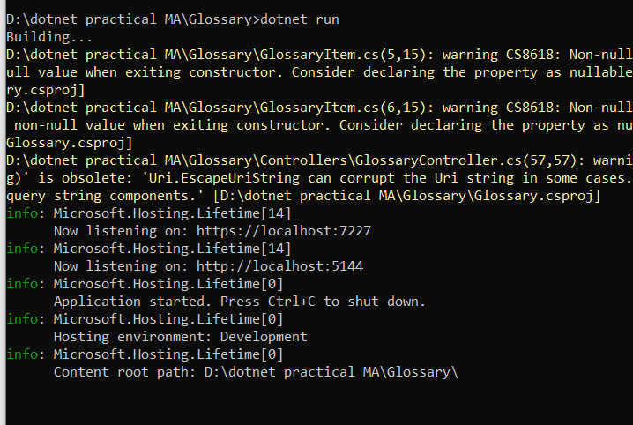
Step 7:
- Getting a list of items:
- Getting a single item
- Creating an item
- Update Item

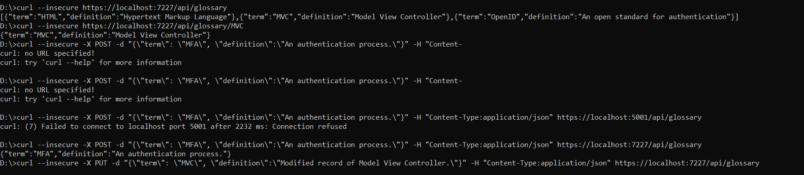
5) Delete Item
Each new command is followed respectively.
Microservice Architecture
Practical #6

Name | Harshal Kadam | Roll Number | 21306A1024
Subject/Course: | Microservice Architecture | Class | MSc IT
Topic | Working with Members API of TeamService | Sem | II
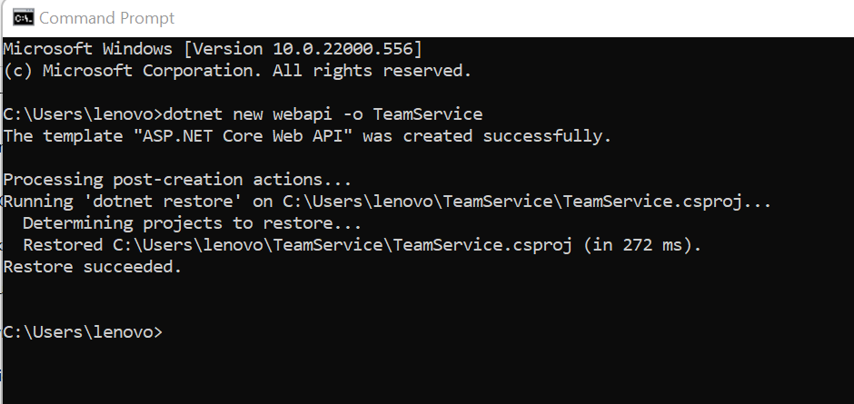
2. Remove existing weatherforecast files both model and controller files.
1. Create new project:
Command :
dotnet new webapi -o TeamService Output:
Working with Members API of TeamService

- Add Member.cs to “D:\TeamService\Models” folder
using System;

namespace TeamService.Models
{
public class Member { public Guid ID { get; set; }
public string FirstName { get; set; } public string LastName { get; set; }

public Member() {
}

public Member(Guid id) : this() { this.ID = id;
}

public Member(string firstName, string lastName, Guid id) : this(id) { this.FirstName = firstName;
this.LastName = lastName;
}

public override string ToString() { return this.LastName;
}
}
}

- Add Team.cs to “D:\TeamService\Models” folder
using System;
using System.Collections.Generic;

namespace TeamService.Models
{
public class Team {

public string Name { get; set; } public Guid ID { get; set; }
public ICollection<Member> Members { get; set; }

public Team()
{
this.Members = new List<Member>();
}

public Team(string name) : this()
{
this.Name = name;
}

public Team(string name, Guid id) : this(name)
{
this.ID = id;
}

public override string ToString() { return this.Name;
}
}
}

5. Add TeamsController.cs file to “D:\TeamService\Controllers” folder
using System;
using Microsoft.AspNetCore.Hosting; using Microsoft.AspNetCore.Builder; using Microsoft.AspNetCore.Mvc; using System.Collections.Generic; using System.Linq;
using TeamService.Models; using System.Threading.Tasks; using TeamService.Persistence;

namespace TeamService
{
[Route("[controller]")]
public class TeamsController : Controller
{
ITeamRepository repository;

public TeamsController(ITeamRepository repo)
{
repository = repo;
}

[HttpGet]
public virtual IActionResult GetAllTeams()
{
return this.Ok(repository.List());
}

[HttpGet("{id}")]
public IActionResult GetTeam(Guid id)
{
Team team = repository.Get(id);

if (team != null) // I HATE NULLS, MUST FIXERATE THIS.
{
return this.Ok(team);
} else {

return this.NotFound();
}
}

[HttpPost]
public virtual IActionResult CreateTeam([FromBody]Team newTeam)
{
repository.Add(newTeam);

//TODO: add test that asserts result is a 201 pointing to URL of the created team.
//TODO: teams need IDs
//TODO: return created at route to point to team details return this.Created($"/teams/{newTeam.ID}", newTeam);
}

[HttpPut("{id}")]
public virtual IActionResult UpdateTeam([FromBody]Team team, Guid id)
{
team.ID = id;

if(repository.Update(team) == null) { return this.NotFound();
} else {
return this.Ok(team);
}
}

[HttpDelete("{id}")]
public virtual IActionResult DeleteTeam(Guid id)
{
Team team = repository.Delete(id);

if (team == null) {
return this.NotFound();
} else {
return this.Ok(team.ID);
}
}
}
}

6. Add MembersController.cs file to “D:\TeamService\Controllers” folder
sing System;
using Microsoft.AspNetCore.Hosting; using Microsoft.AspNetCore.Builder; using Microsoft.AspNetCore.Mvc; using System.Collections.Generic; using System.Linq;
using TeamService.Models; using System.Threading.Tasks;

using TeamService.Persistence;

namespace TeamService
{
[Route("/teams/{teamId}/[controller]")] public class MembersController : Controller
{
ITeamRepository repository;

public MembersController(ITeamRepository repo)
{
repository = repo;
}

[HttpGet]
public virtual IActionResult GetMembers(Guid teamID)
{
Team team = repository.Get(teamID);

if(team == null) {
return this.NotFound();
} else {
return this.Ok(team.Members);
}
}

[HttpGet] [Route("/teams/{teamId}/[controller]/{memberId}")]
public virtual IActionResult GetMember(Guid teamID, Guid memberId)
{
Team team = repository.Get(teamID);

if(team == null) {
return this.NotFound();
} else {
var q = team.Members.Where(m => m.ID == memberId);

if(q.Count() < 1) {
return this.NotFound();
} else {
return this.Ok(q.First());
}
}
}

[HttpPut] [Route("/teams/{teamId}/[controller]/{memberId}")]
public virtual IActionResult UpdateMember([FromBody]Member updatedMember, Guid teamID,
Guid memberId)

{
Team team = repository.Get(teamID);

if(team == null) {
return this.NotFound();
} else {
var q = team.Members.Where(m => m.ID == memberId);

if(q.Count() < 1) {
return this.NotFound();
} else { team.Members.Remove(q.First()); team.Members.Add(updatedMember); return this.Ok();
}
}
}

[HttpPost]
public virtual IActionResult CreateMember([FromBody]Member newMember, Guid teamID)
{
Team team = repository.Get(teamID);

if(team == null) {
return this.NotFound();
} else { team.Members.Add(newMember);
var teamMember = new {TeamID = team.ID, MemberID = newMember.ID};
return this.Created($"/teams/{teamMember.TeamID}/[controller]/{teamMember.MemberID}", teamMember);
}
}

[HttpGet] [Route("/members/{memberId}/team")]
public IActionResult GetTeamForMember(Guid memberId)
{
var teamId = GetTeamIdForMember(memberId); if (teamId != Guid.Empty) {
return this.Ok(new { TeamID = teamId
});
} else {
return this.NotFound();
}
}

private Guid GetTeamIdForMember(Guid memberId)
{
foreach (var team in repository.List()) {

var member = team.Members.FirstOrDefault( m => m.ID == memberId); if (member != null) {
return team.ID;
}
}
return Guid.Empty;
}
}
}

- Create folder “D:\TeamService\Persistence”:
- Add file ITeamReposiroty.cs in “D:\TeamService\Persistence” folder
using System;
using System.Collections.Generic; using TeamService.Models;

namespace TeamService.Persistence
{
public interface ITeamRepository { IEnumerable<Team> List(); Team Get(Guid id);
Team Add(Team team); Team Update(Team team); Team Delete(Guid id);
}
}

- Add MemoryTeamRepository.cs in “D:\TeamService\Persistence” folder
using System;
using System.Collections.Generic; using System.Linq;
using TeamService;
using TeamService.Models;

namespace TeamService.Persistence
{
public class MemoryTeamRepository : ITeamRepository { protected static ICollection<Team> teams;

public MemoryTeamRepository() { if(teams == null) {
teams = new List<Team>();
}
}

public MemoryTeamRepository(ICollection<Team> teams) { MemoryTeamRepository.teams = teams;
}

public IEnumerable<Team> List() {

return teams;
}

public Team Get(Guid id) {
return teams.FirstOrDefault(t => t.ID == id);
}

public Team Update(Team t)
{
Team team = this.Delete(t.ID);

if(team != null) { team = this.Add(t);
}

return team;
}

public Team Add(Team team)
{
teams.Add(team); return team;
}

public Team Delete(Guid id) {
var q = teams.Where(t => t.ID == id); Team team = null;

if (q.Count() > 0) { team = q.First();
teams.Remove(team);
}

return team;
}
}
}

- Add following line to Startup.cs in public void ConfigureServices(IServiceCollection services) method
services.AddScoped<ITeamRepository,MemoryTeamRepository>();

- Now open two command prompts to run this project
- On Command prompt 1: (go inside folder teamservice first) Commands:
dotnet run
Output:

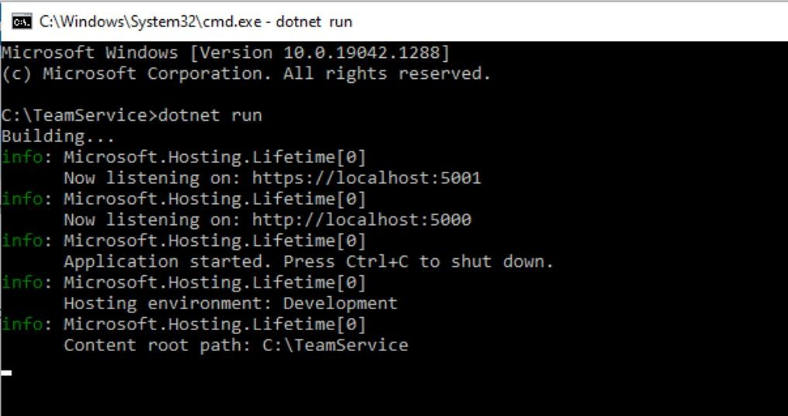

- On command prompt 2
Command:
  - To get all teams:
curl --insecure https://localhost:5001/teams
  - To create new team
curl --insecure -H “Content-Type:application/json” –X POST –d “{\“id\”:\”e52baa63-d511- 417e-9e54-7aab04286281\”, \”name\”:\”KC\”}” https://localhost:5001/teams
  - To create one more new team
curl --insecure -H “Content-Type:application/json” –X POST –d “{\“id\”:\”e12baa63-d511- 417e-9e54- 7aab04286281\”, \”name\”:\”MSC Part1\”}” https://localhost:5001/teams
  - To get all teams
curl --insecure https://localhost:5001/teams
  - To get single team with team-id as parameter
curl --insecure https://localhost:5001/teams/e52baa63-d511-417e-9e54-7aab04286281
  - To update team details (change name of first team from “KC” to “KC IT DEPT”) curl --insecure -H “Content-Type:application/json” –X PUT –d “{\“id\”:\”e52baa63-d511- 417e-9e54- 7aab04286281\”, \”name\”:\”KC IT DEPT\”}” https://localhost:5001/teams/e52baa63-d511-417e-9e54- 7aab04286281
  - To delete team
curl --insecure -H “Content-Type:application/json” –X DELETE https://localhost:5001/teams/e52baa63-d511-417e9e54-7aab04286281
  - With get all teams now it shows only one team (first one is deleted)
curl –insecure https://localhost:5001/teams
  - To create team (to add member team must exist)
curl --insecure -H “Content-Type:application/json” –X POST –d “{\“id\”:\”e52baa63-d511- 417e-9e54- 7aab04286281\”, \”name\”:\”KC\”}” https://localhost:5001/teams
  - To add new member to above team

curl --insecure -H “Content-Type:application/json” –X POST –d “{\"id\":\"63e7acf8-8fae- 42ce-9349- 3c8593ac8292\", \"firstName\":\"Kirti\", \"lastName\":\"Bhatt\"}” https://localhost:5001/teams/e52baa63- d511-417e-9e54-7aab04286281/members
- Now it shows newly added member in team
curl --insecure https://localhost:5001/teams/e52baa63-d511-417e-9e54-7aab04286281
- To get individual member details
curl --insecure https://localhost:5001/teams/e52baa63-d511-417e-9e54- 7aab04286281/members/63e7acf8- 8fae-42ce-9349-3c8593ac8292
- To add one more member to same team
curl --insecure -H “Content-Type:application/json” –X POST –d “{\"id\":\"64e7acf8-8fae- 42ce-9349- 3c8593ac8292\", \"firstName\":\"Anushka\", \"lastName\":\"Bhatt\"}” https://localhost:5001/teams/e52baa63- d511-417e-9e54-7aab04286281/members
- To check all members
curl --insecure https://localhost:5001/teams/e52baa63-d511-417e-9e54- 7aab04286281/members
- To change details of member: changing first name
curl --insecure -H “Content-Type:application/json” –X PUT –d “{\"id\":\"63e7acf8-8fae- 42ce-9349- 3c8593ac8292\", \"firstName\":\"Soniya\", \"lastName\":\"Bhatt\"}” https://localhost:5001/teams/e52baa63- d511-417e-9e54- 7aab04286281/members/63e7acf8-8fae-42ce-9349-3c8593ac8292

Output:
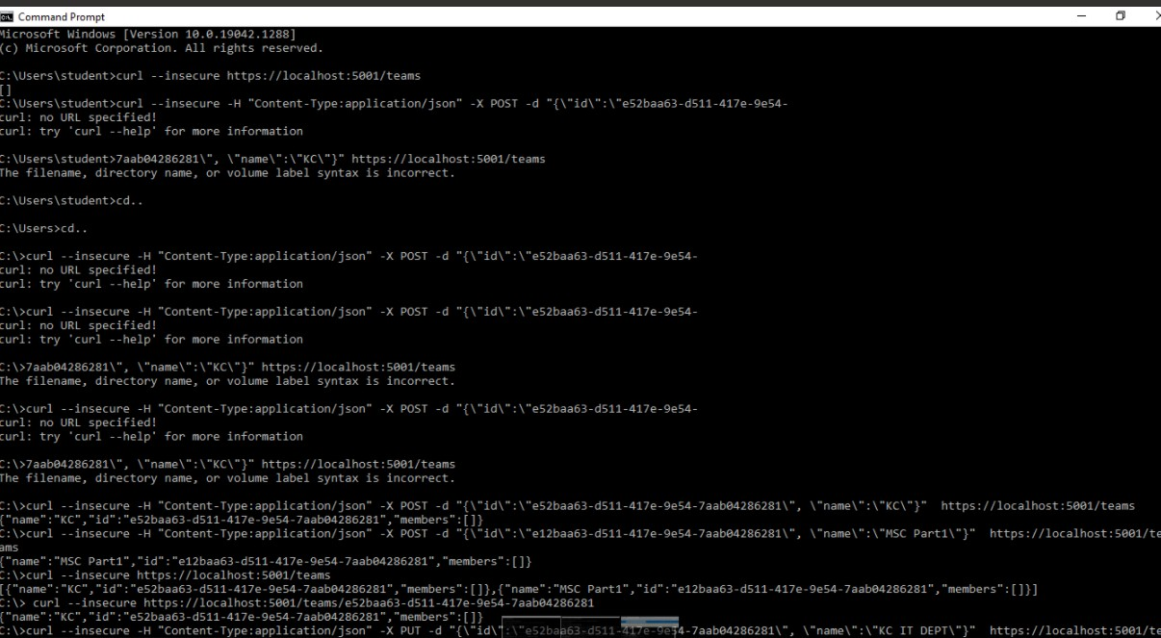

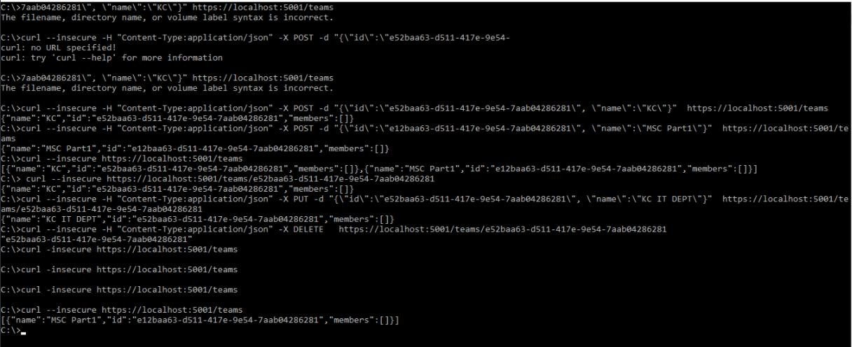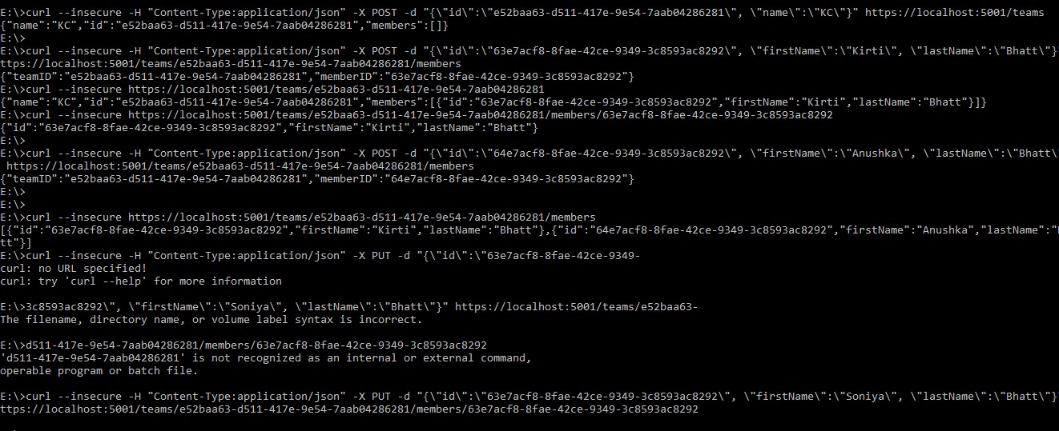

Example 2

Microservice Architecture
Practical #7

Name | Harshal Kadam | Roll Number | 21306A1024
Subject/Course: | Microservice Architecture | Class | MSc IT
Topic | Running Location Service | Sem | II
Overview of Location Service

Running Location Service
(1) Running Location Service Locally using .Net core
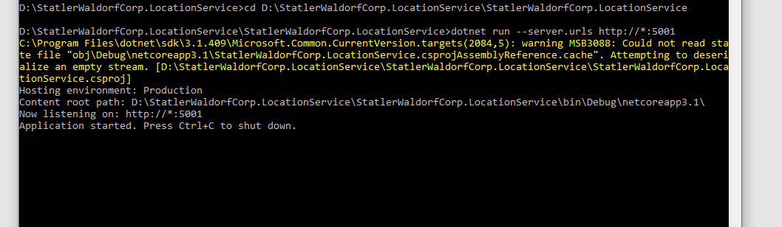

(2) Running Location Service in Docker
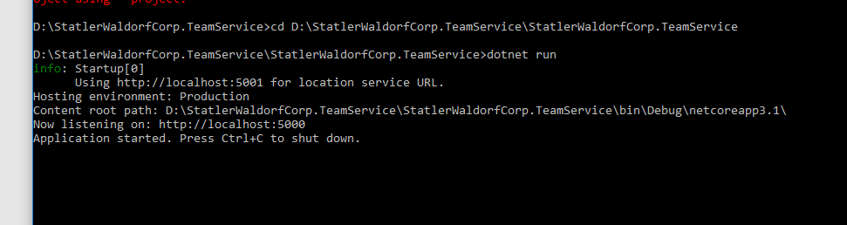
Step 3:
- Command to Add new team: curl -H "Content-Type:application/json" -X POST -d "{\"id\":\"e52baa63-d511-417e- 9e54-7aab04286281\", \"name\":\"KC\"}" http://localhost:5000/teams
- Command: to add new member to team curl -H "Content-Type:application/json" -X POST -d "{\"id\":\"63e7acf8- 8fae-42ce-9349-3c8593ac8292\", \"firstName\":\"Kirti\", \"lastName\":\"Bhatt\"}" http://localhost:5000/teams/e52baa63-d511-417e-9e54-7aab04286281/members
- Command to Add location for member curl -H "Content-Type:application/json" -X POST -d "{\"id\":\"64c3e69f- 1580-4b2f-a9ff-2c5f3b8f0e1f\", \"latitude\":12.0,\"longitude\":12.0,\"altitude\":10.0,
\"timestamp\":0,\"memberId\":\"63e7acf8-8fae-42ce-9349-3c8593ac8292\"}" http://localhost:5001/locations/63e7acf8-8fae-42ce-9349-3c8593ac8292
- Command To confirm it is accessible from teams (that is from port 5000) it shows last location curl http://localhost:5000/teams/e52baa63-d511-417e-9e54-7aab04286281/members/63e7acf8-8fae-42ce-9349- 3c8593ac8292

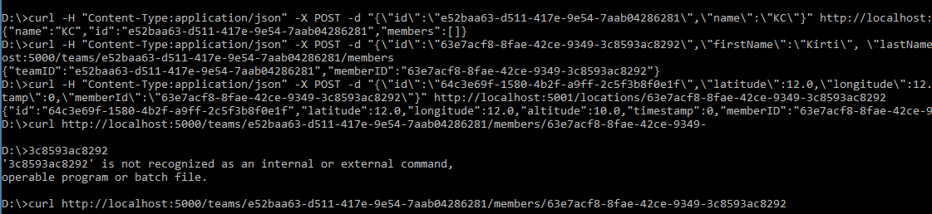
(2)Running Location Service in Docker Login to Docker

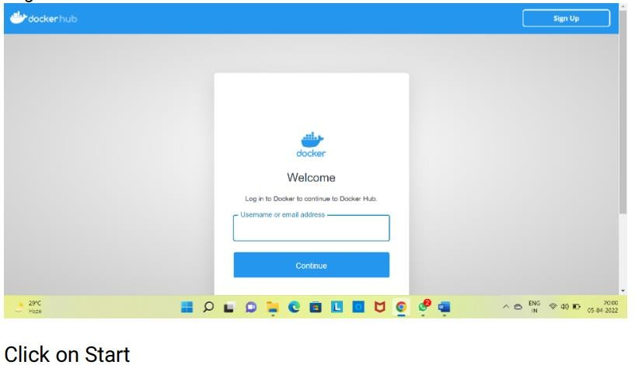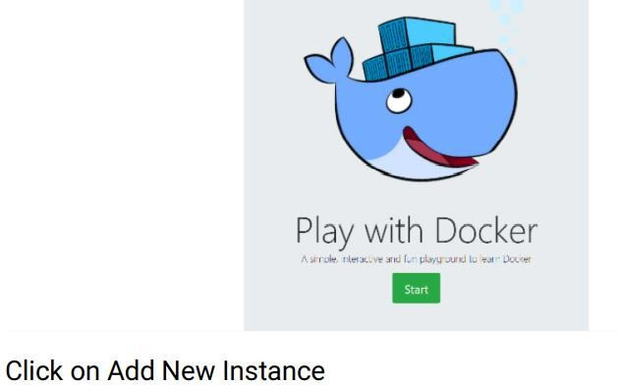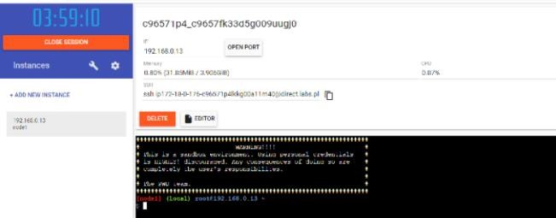
Command: To run team service dockerrun-d-p5000:5000-ePORT=5000\ -e LOCATION URL=http://localhost:5001\ dotnet core services/team service: location

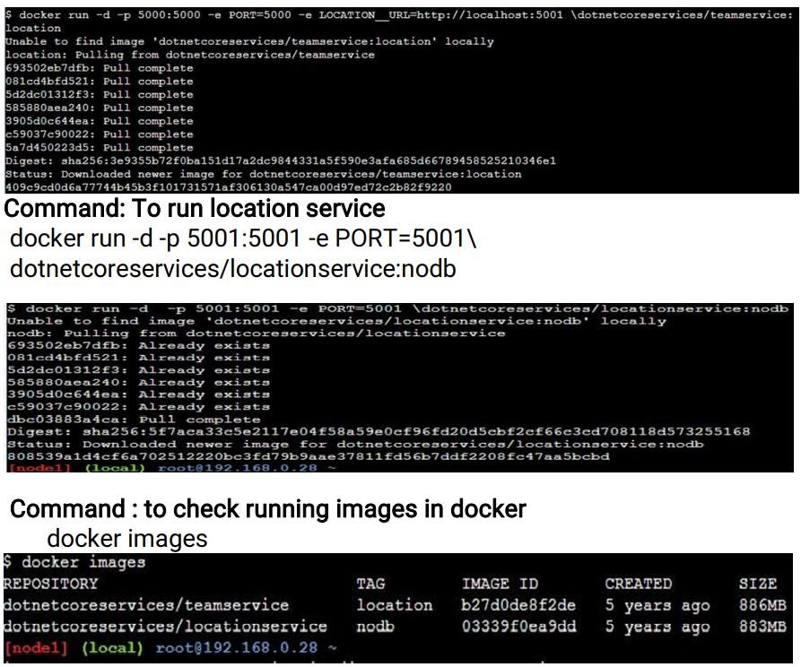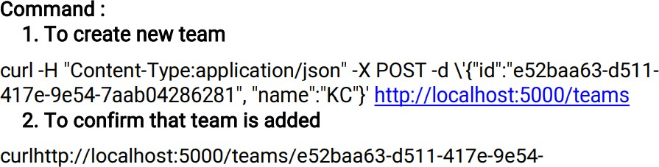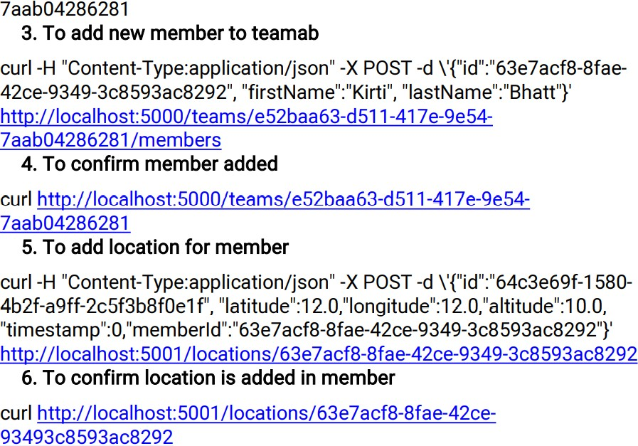

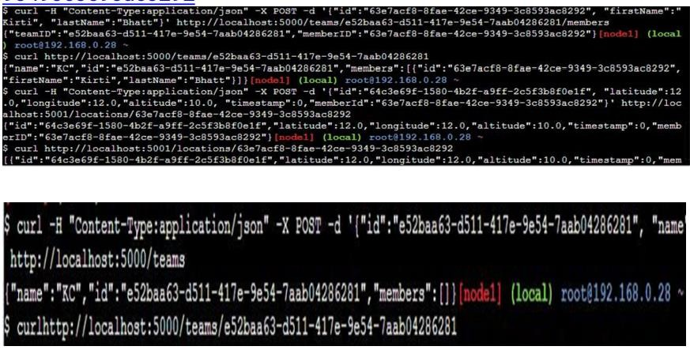
Microservice Architecture
Practical #8

Name | Harshal Kadam | Roll Number | 21306A1024
Subject/Course: | Microservice Architecture | Class | MSc IT
Topic | Create a backing Service using ASP .NET | Sem | II

First we have installed the packages then we have opend 5 command prompt in 1st cmd we have started team service in 2nd cmd we have added location reports in 3rd cmd we have started event processor in 4th cmd we have started reality service in 5th command prompt we have added a team then we have added a members and its location in to the teams.
Overview of Event Sourcing

First install following softwares:
1)install erland broker using OTP AND Radis cache 2)then install rabbitmq server
- open folder “C:\Users\Admin\AppData\Roaming\RabbitMQ\db” and delete everything
inside it
- now run RabbitMQ sbin command prompt as administrator
- and type following commands: rabbitmq-service remove rabbitmq-service install
Event Sourcing and CQRS Example

rabbitmq-server restart
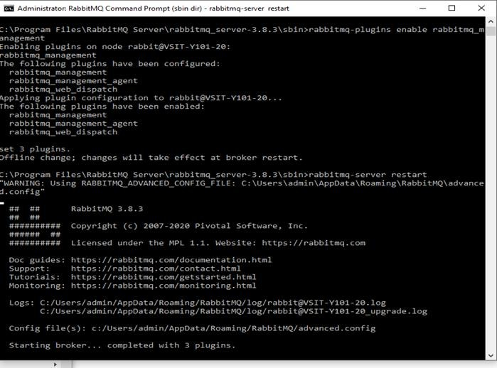

- Now open web browser (crome) and type following URL http://localhost:15672
- It will show login page: here type username as “guest” and password as “guest” and login.

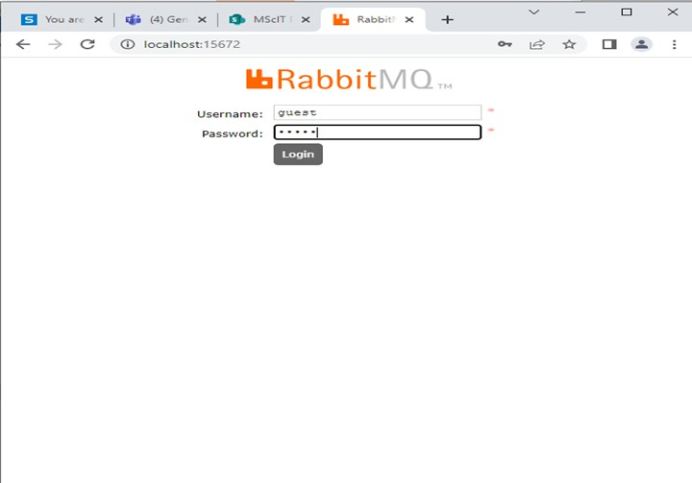
- Now open 5 command prompts
- On command prompt 1 start team service for that go inside teamservice project folder and write command :
dotnet run –server.urls=http://0.0.0.0:5001

Output:

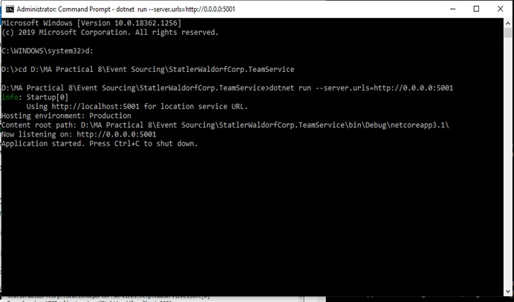
- On command prompt 2 start LocationReports service for that go inside LocationReporter project folder and write command :
dotnet run –server.urls=http://0.0.0.0:5002 Output:

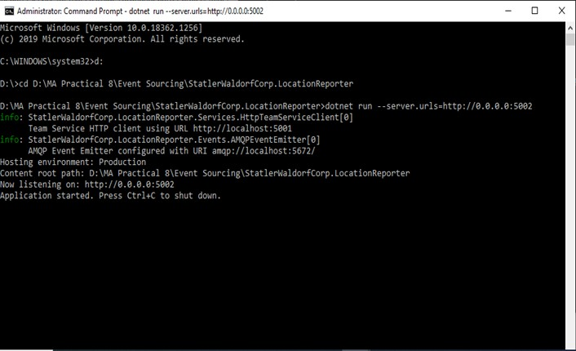
- On command prompt 3 start EventProcessor service for that go inside EventProcessor project folder and write command :
dotnet run –server.urls=http://0.0.0.0:5003

Output :

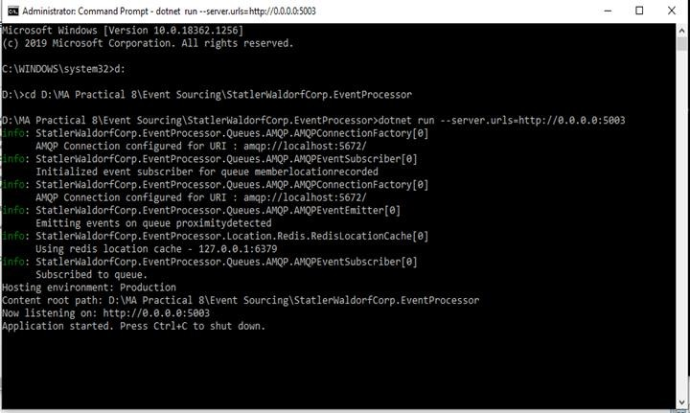
- On command prompt 4 start Reality service for that go inside Reality project folder and write command :
dotnet run –server.urls=http://0.0.0.0:5004 Output:
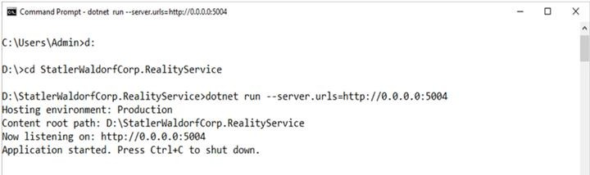
- Now run all commands on command prompt 5 Command: to add new team
curl -H "Content-Type:application/json" -X POST -d "{\"id\":\"e52baa63-d511-417e-9e54- 7aab04286281\", \"name\":\"KC\"}" http://localhost:5001/teams

Output:

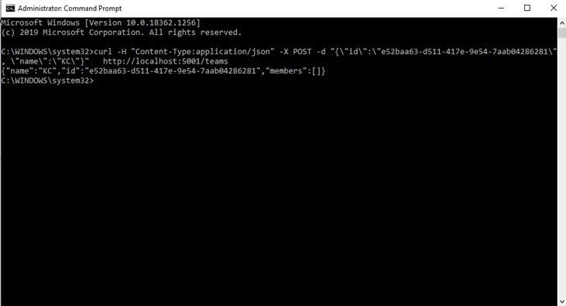
Command : to add new member
curl -H "Content-Type:application/json" -X POST -d "{\"id\":\"63e7acf8-8fae-42ce-9349- 3c8593ac8292\", \"firstName\":\"Kirti\", \"lastName\":\"Bhatt\"}" http://localhost:5001/teams/e52baa63-d511-417e-9e54-7aab04286281/members

Output:

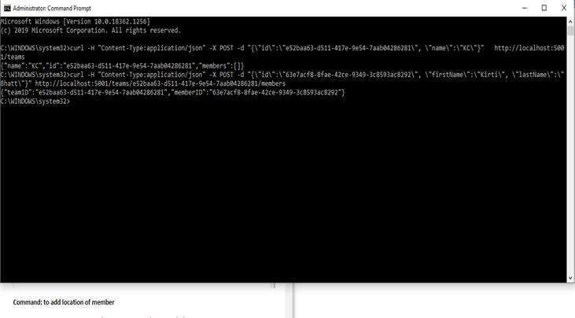
Command: to add location of member
curl -H "Content-Type:application/json" -X POST -d "{\"reportid\":\"67c3e69f-1580-4b2f-a9ff- 2c5f3b8f0e1f\",\"origin\":\"1234\",\"latitude\":12.5,\"longitude\":12.5,\"memberId\":\"63e7 acf8-8fae-42ce-9349-3c8593ac8292\"}" http://localhost:5002/api/members/63e7acf8-8fae- 42ce-9349-3c8593ac8292/locationreports

Output:

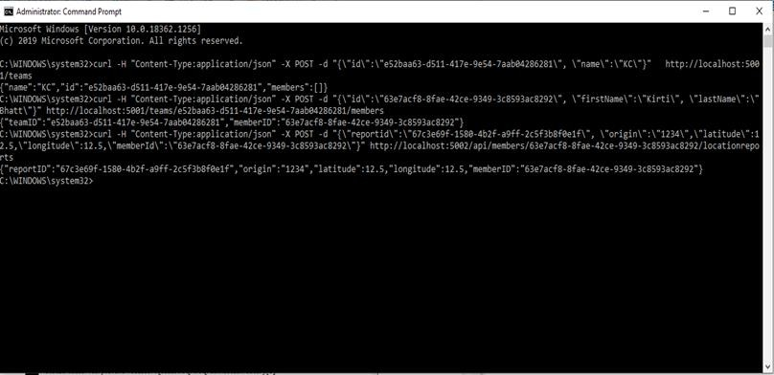
Output of event processor shows event received
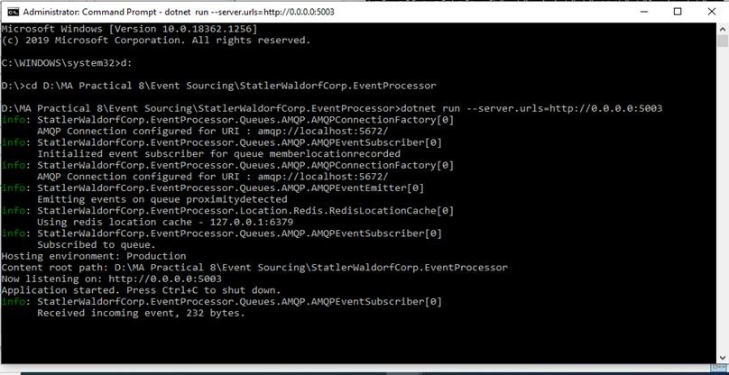
Output on RabbitMQ shows 2 Queues created
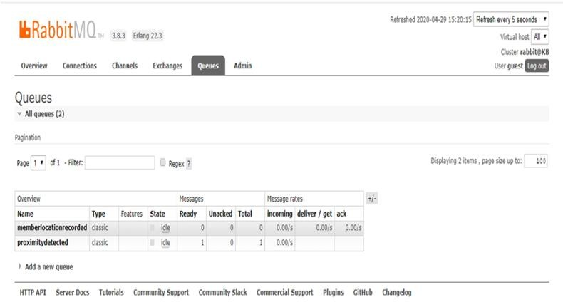
Command : To add another member to same Team
curl -H "Content-Type:application/json" -X POST -d "{\"id\":\"68e7acf8-8fae-42ce-9349- 3c8593ac8292\", \"firstName\":\"Anushka\", \"lastName\":\"Bhatt\"}" http://localhost:5001/teams/e52baa63-d511-417e-9e54-7aab04286281/members

Output:

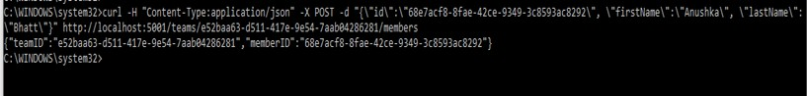
Command : To add location of this another member of same team
curl -H "Content-Type:application/json" -X POST -d "{\"reportid\":\"70c3e69f-1580-4b2f-a9ff- 2c5f3b8f0e1f\",\"origin\":\"1234\",\"latitude\":12.7,\"longitude\":12.8,\"memberId\":\"68e7 acf8-8fae-42ce-9349-3c8593ac8292\"}" http://localhost:5002/api/members/68e7acf8-8fae- 42ce-9349-3c8593ac8292/locationreports
Output:

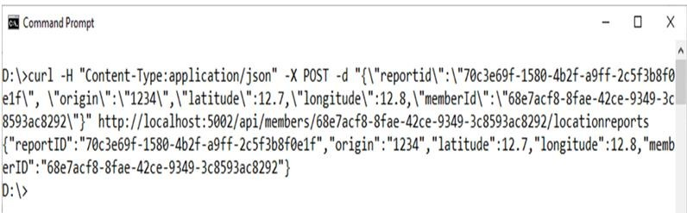

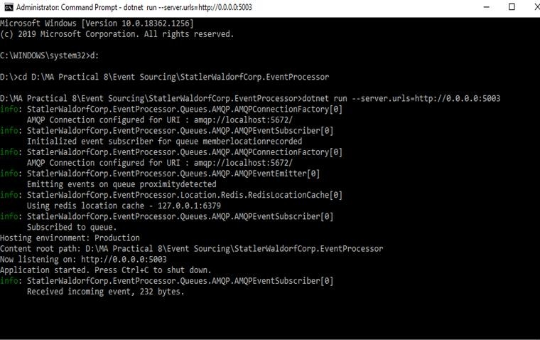

Microservice Architecture
Practical #9

Name | Harshal Kadam | Roll Number | 21306A1024
Subject/Course: | Microservice Architecture | Class | MSc IT



Topic | Building an ASP.NET Core Web Application | Sem | II

Overview of ASP.NET Core Web Application
ASP.NET Core is a cross-platform, high-performance, open-source framework for building modern, cloud-enabled, Internet - connected apps.
- Build webapps and services, Internet of Things(IoT) apps ,and mobile backends.
- Use your favourite development tools on Windows, macOS, and Linux.
- Deploy to the cloud or on-premises. Run on .NETCore

Building an ASP.NET Core Web Application
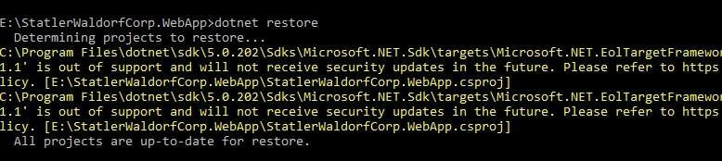

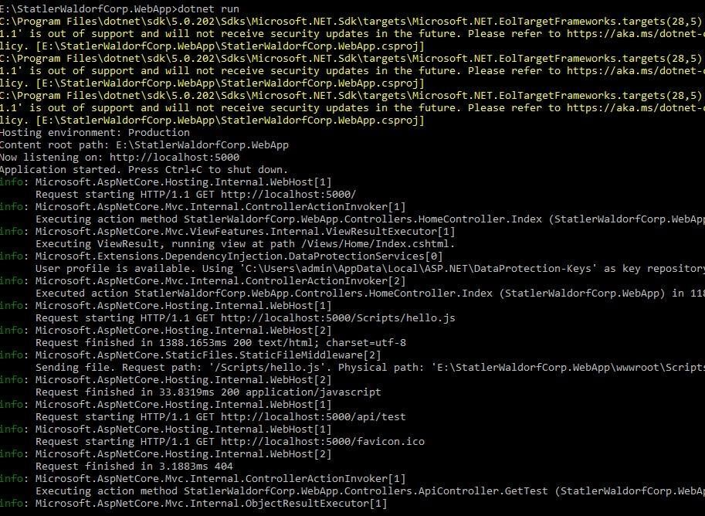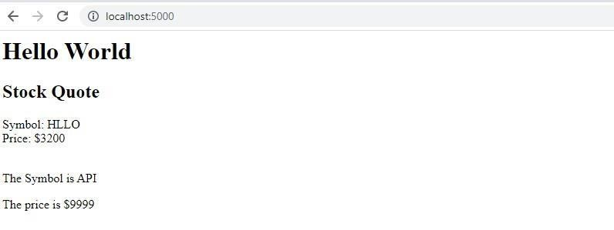

Microservice Architecture
Practical #10

Name | Harshal Kadam | Roll Number | 21306A1024
Subject/Course: | Microservice Architecture | Class | MSc IT
Topic | Working with docker Volumes and Networks. | Sem | II
Explain how containers persist data in the host filesystem?

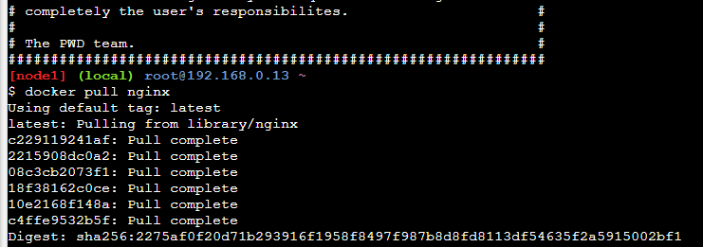Working with docker Volumes and Networks.

1)Pull nginx image into docker Command: docker pull nginx
Output:

2)Now run the pulled image in Conatiner named “webApp”
Command: docker run -it --name=webApp -d -p 80:80 nginx

Output:

3)

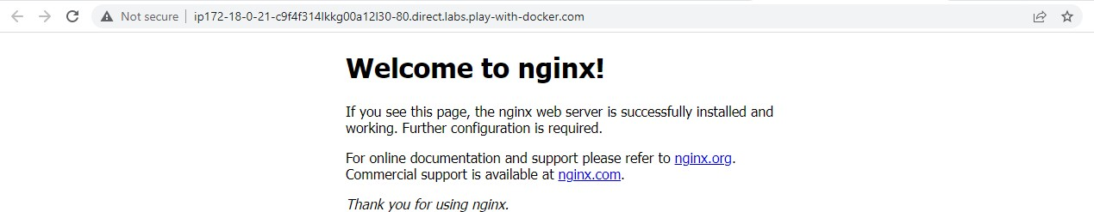

4)We make changes into “index.html” file inside
/usr/share/nginx/html folder
Commands: 1)docker exec -it webApp bash //this command to execute bash shell
- cd /usr/share/nginx/html // to go inside html folder
- echo "Hello KB" > index.html // to change content of index.html file

Output:
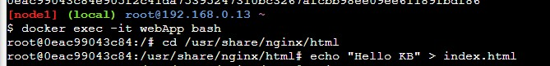

5)Type exit to return to docker prompt and check process status using ps option
Commands: exit docker ps
output:
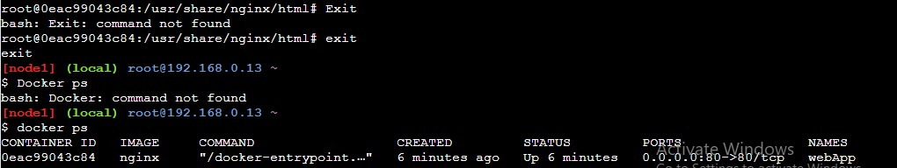

6)

7)
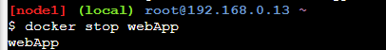

8)Start nginx in new container named as “webApp1”. Command: docker run -it --name=webApp1 -d -p 80:80 nginx
Output:

9)
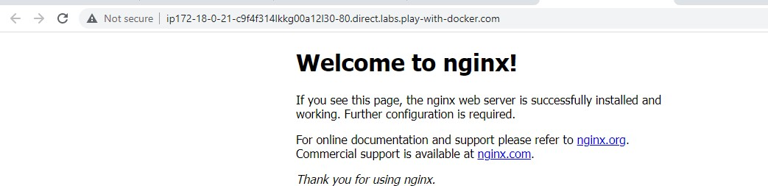

10)To solve this issue we create new volume. Command: docker volume create MyVolume

Output:
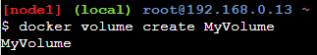

- Check details of volume
Command: docker volume inspect MyVolume Output:
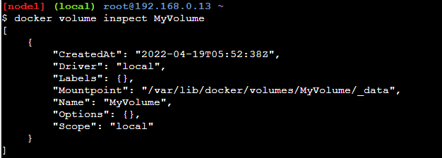
- Mount this volume to nginx new container named
“webApp4”
Command: docker run -d --name=webApp4 --mount source=MyVolume,destination=/usr/share/nginx/html -p 80:80 nginx
Output:

- Now keep on doing “ls” and “cd “ to go inside _data
folder of our volume “MyVolume”
Commands: 1)ls / 2)cd /var/lib/docker 3)ls

Output:

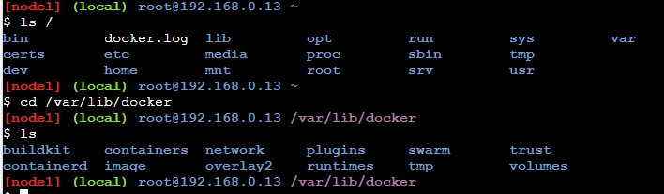
- cd volumes
- ls
- cd MyVolume
- ls
Output:
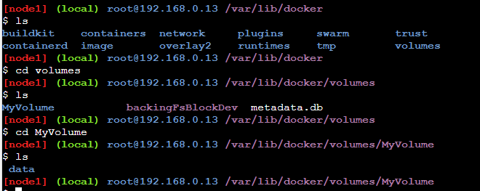

Commands: cd _data
Ls Output:

\
16)Now refersh port 80 (to get modified output)
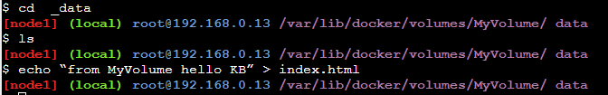

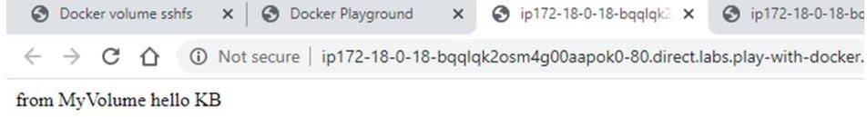
- Now stop this running container named “webApp4”
Command: docker stop webApp4 Output:

- Now run nginx in new container named “webApp6” Command: docker run -d --name=webApp6 --mount source=MyVolume,destination=/usr/share/nginx/html -p 80:80 ngin
output:

